CSE220: Data Structures (Lab)

Fall 2024

Lab Quiz - 05

Duration: 30 Minutes

| Name: | ID: | Section: |
| --- | --- | --- |

### **Question 1 [15 Points]**

In this task you will be given the root node of a binary search tree. You need to calculate the **Product** of the values of the nodes that are **mirrors** of each other. Here, mirror means the nodes that are located in **corresponding positions in the left and right subtrees**. You need to define the **Node class** for the Binary Tree. You can use **helper functions**.

**Example Tree input 1**   **Example Tree input 2**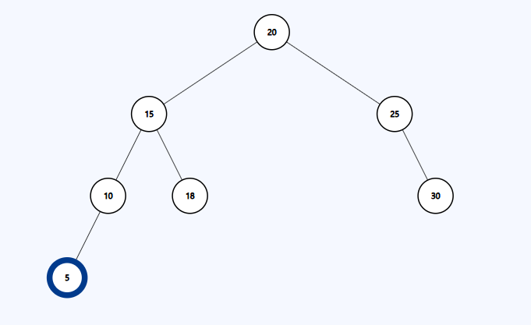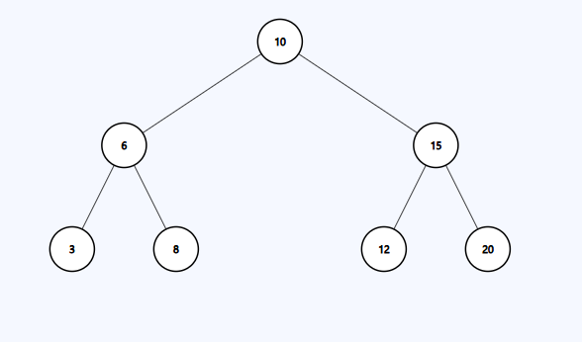

| **Sample Input** | **Sample Output** | **Explanation** |
| --- | --- | --- |
| mirror(root) | 518400 | For Tree 1 Mirror nodes are:  6 and 15, product = 6 * 15 = 90  3 and 20, product = 3 * 20 = 60  8 and 12, product = 8 * 12 = 96  Total Mirror Node product = 90*60*96 = 518400 |
| mirror(root) | 112500 | For Tree 2 Mirror nodes are:  15 and 25, product = 15 * 25 = 375  10 and 30, product = 10 * 30 = 300  Total Mirror Node product = 375 * 300 = 112500 |